Beijing

Xi Cheng District

Shuanghua Street 100040

010-67398273

May 28, 2015

Shuanghua SchoolS

Shuanghua Street

TX 798757

**ATTENTION:** Mr. Bai Hongkuan, Principal

**APPLICATION AND PROSPECT OF MOBILE INTERNET**

**INTRODUCTORY SUMMARY**

Cognize the development of mobile Internet, and have a certain degree of evaluation on its advantages and disadvantages. Making the mobile Internet questionnaire, randomly distributed and analyze the data. Figure out the main purpose of using the mobile Internet, and the trend of development of mobile Internet in the future.

The mobile Internet refers to access to the world wide web, i.e. the use of browser-based Internet services, from a handheld mobile device, such as a smartphone or a feature phone, connected to a mobile network or other wireless network. An early 2010 ITU (International Telecommunication Union) report said that with the current growth rates, web access by people on the go — via laptops and smart mobile devices – is likely to exceed web access from desktop computers within the next five years. So we has launched the investigation for the mobile Internet.

**SURVEY METHOD AND PROCESS**

1. **The survey overview**

I have researched in two methods, questionnaire on wechat and street interview. The contents of the questionnaire is about the current situation of the usage of mobile Internet on respondents. According to the data analysis, we obtain the use situation to the mobile Internet in recent years. And we can have prospect about the development trend of mobile Internet.

1. **The survey process**

Firstly, for the questionnaire making, I made reference to several resemble questionnaire about mobile Internet to have a general grasp about the content. Then I considered that the object of this investigation is majority of students in reading, so I modified the questionnaire and got the final version. The question is about the time, volume of mobile Internet, operators selection and their view on mobile Internet development etc. In order to get the volume, purpose of use mobile network and its mode of distribution in population. The number of samples is obtained with reference value for a total of 268.

**DATA ANALYSIS OF SURVEY RESULTS**

That is the most important part in this research. We have investigated a sample of 268, including 252 students, the remaining 16 for office workers. As the same time, 89.55% of respondents in the 18-35 years of age, and 85.07% of respondents used Internet over 5 years. That shows our investigation can clear Internet is more popular among young people and their reaction as the Internet user.

The survey found that the majority of respondents were more willing to use mobile phone access to the Internet, and that mobile phone has become an indispensable part in their lives. Nowadays, the rapid development of mobile Internet, 2G, 3G, 4G update soon and it also has a fast transmission speed. Many Internet Co are in the promotion of 4G mobile. Analysis of the development trend of mobile Internet.

However, there is a big obstacle to the popularity of mobile internet. “As the mobile data is too expensive to use hourly.”, reflected by 71.9% of responds. Similarly, the unreasonable charge method is a major issue. In addition, the unstable signal and slow transmission speed also need to be solve. After that, the operators can prevent the loss of existing customers and attract more new users, in order to make themselves better develop.

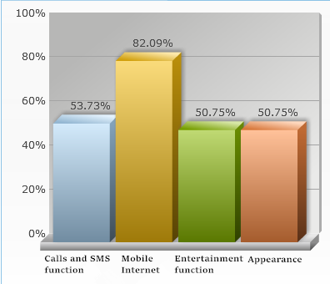

1. Which function of smartphone people care about

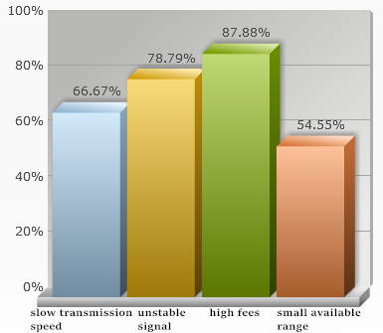

1. Problem with operators

**PROSPECT**

The last question on the sheet is about their opinion of the development prospects of the mobile Internet. Most of the responds are very optimistic about the future development. Also some respondents said, the development of science and technology will make the price decline of mobile Internet, people will use it more frequently. When the mobile Internet market is already saturated, the future development should be stable.

In my opinion, the Client oriented mobile Internet market has developed very rapidly. But the mobile Internet can produce a great value, the domestic operators just have dug a small part of it for now. According to the data, we found that they pitch it as a service and a

Basement of various value-added service. In fact the value of the mobile Internet has further space to mine completely. Smartphone ownership is 270 million units in China, we forecast the number will reach more than 500 million next year. And almost all the app on smartphone depends on the mobile Internet. That will be a gigantic data between customer and operator. The value of data should not limit in the Data traffic fee but the data itself. Through data analysis, we can get lots of information about the customers, the hobby sites and application and so on. This is a little part of the potential value. And how to have the final value? It need we work together. I have confidence in the industry's future.

Finally, I have some prospect on the mobile phone app. First of all, many app can not find their niche. Like singing bar, Moji weather, they obtain millions of user. But there are still not a proper method to get profit. I think maybe mobile app should more attach to the hardware devices. Wearable devices such as fitness bracelet, the App would become a entrance supporting the device.

**CONCLUSIONS**

In short, all of this is a idea which need to practice. Through this research, I found myself growing. Such a survey, it brings me great benefits, let's exercise of rational thinking, and make a solid foundation for the future.

I will meet you to discuss our study and any follow-up you may wish us to do.

Sincerely,

Yue Lin

Research Group Leader